**RESEARCH PLAN**

Group Members: **Lea Monique Clarin, Sharon Olorunniwo, Michelle Sin, Quinn Harder, Jimmy Quach**

Due: **Wednesday, January 30**

**1. WHO OR WHAT WILL WE STUDY?**

* Generation Z (1995-2005); particularly current University students at the University of Waterloo and within the City of Waterloo (birth years of 1996 - 2000 and who are enrolled at UW/WLU in 2018-2019 school year)
* We will study the values, perceptions, and behaviors (interaction points) that Gen Z young adults have/display toward banking and financial institutions
* Objective/Design Challenge: “How might TD better establish a value-based relationship with Generation Z that is grounded in trust and reciprocity?”
* Aside: We could take the route of interviewing students in their last year of high-school/second last year of highschool/1st year of university as this is great time for TD to build a relationship early???

**2. WHERE WILL WE FIND THE PEOPLE OR INFO?**

**People**

* Waterloo & Laurier Campus (SLC, Wilf’s, etc.)
* Network (family, friends, and peers)
* Bank locations (within 3 km of all campuses)
  + 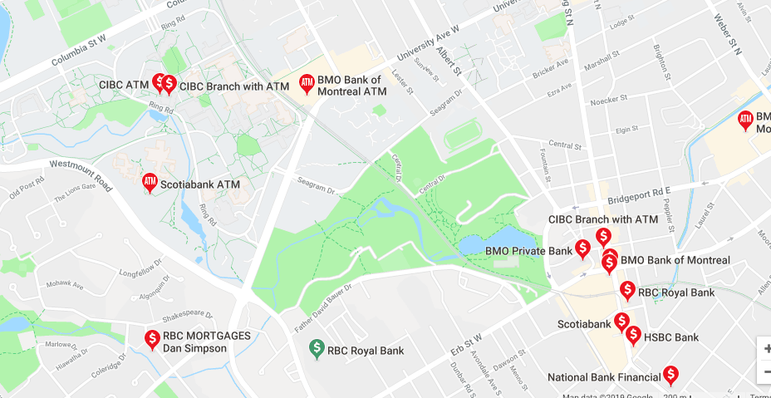
* Greater City of Waterloo community (i.e. bus stops)

WHO HAS AMPLIFIED NEEDS?

* Exchange students! (don’t speak English well but need bank account, also with money transfers)
* Marginalized youth who are poor, not as financially literate, need transit to go to bank (no car),

**Information Sources**

* Reports
  + [Missing Out: Millennials and the Markets](https://www.getsmarteraboutmoney.ca/resources/publications/research/missing-out-millennials-and-the-markets/)
  + <https://www.aba.com/Tools/Documents/MillennialsInfographicSources.pdf>
  + <https://www.nielsen.com/ca/en/insights/news/2018/millennials-by-the-numbers-quick-facts.html>
* [PRIZM Consumer Segmentation Index](https://www.environicsanalytics.com/en-ca/PRIZM5)

**3. WHAT QUESTIONS WILL WE EXPLORE?**

1. Walk me through the last time you’ve been to your bank - let them tell you stories
2. What do you wish your banking experience could be like?
3. When was the most positive (WOW) customer interaction you’ve had?
4. Describe your ideal banking app. / Tell me about a great experience you’ve had with an app (that uses financial transactions).
5. How would you describe your confidence with your financial literacy?
6. What are your future goals?

**4. NUMBER OF OBSERVATIONS, INTERVIEWS, OR INPUTS**

* [Typeform](https://www.typeform.com/product/?tf_campaign=brand_1484929320&tf_source=google&tf_medium=paid&tf_content=56847576189_283973375901&tf_term=typeform&tf_dv=c&gclid=CjwKCAiAs8XiBRAGEiwAFyQ-et5gtN4uIKsL1T0cBGVRiMMUZqSSe2i2STcVAWRa9nvd22duLLIznxoC6oQQAvD_BwE)
* Perhaps we could make a qualitative coding chart for our interviews?

**5. WHEN WILL THE RESEARCH HAPPEN?**

* Throughout the term leading to the development of the proposed solution to the TD Lab challenge

**6. WHO ON THE TEAM IS RESPONSIBLE?**

* Lea: Design
* Sharon:
* Michelle:
* Quinn:
* Jimmy:

**\*Homework for next week: conduct at least 5 more interviews and 1 survey**

**Jan 23 - 30 Homework:**

_________________________________________________________________________

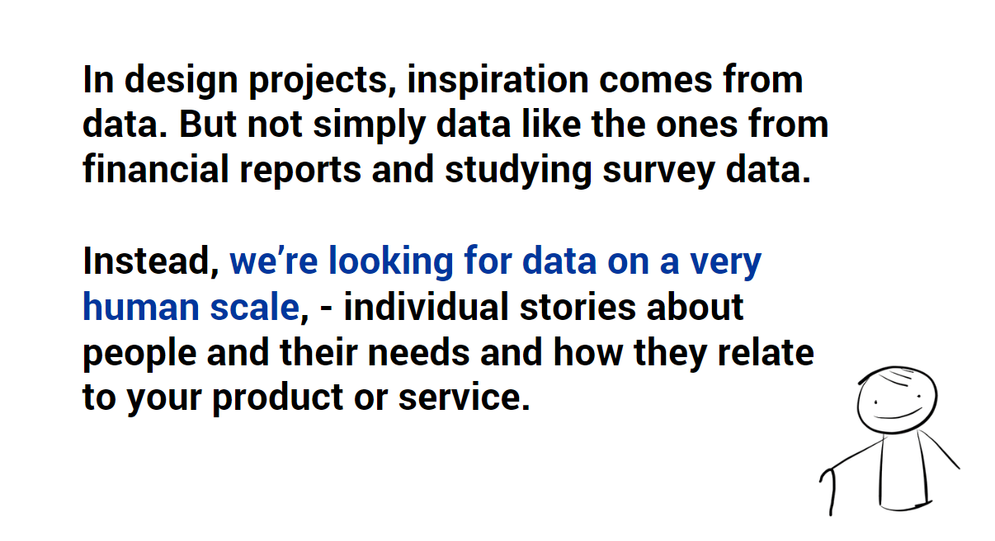

_________________________________________________________________________

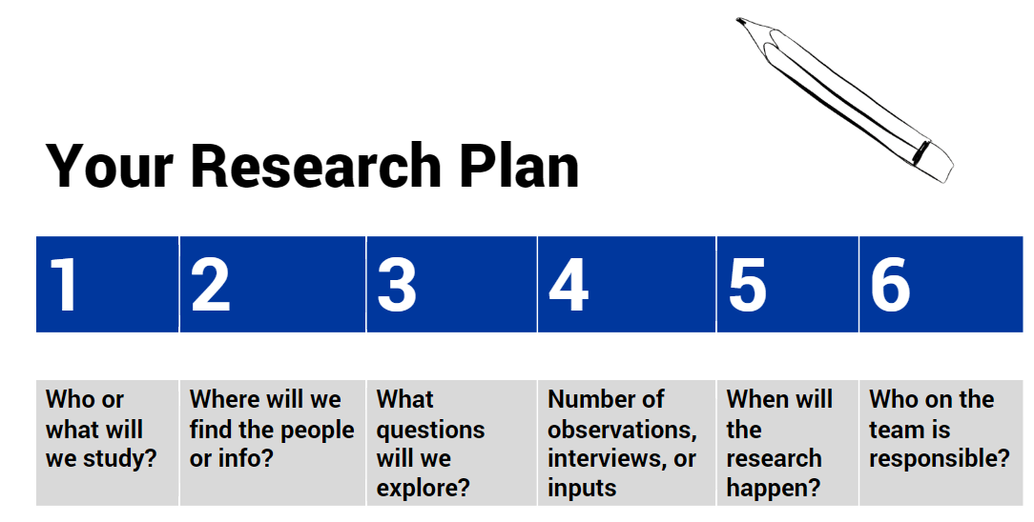

_________________________________________________________________________

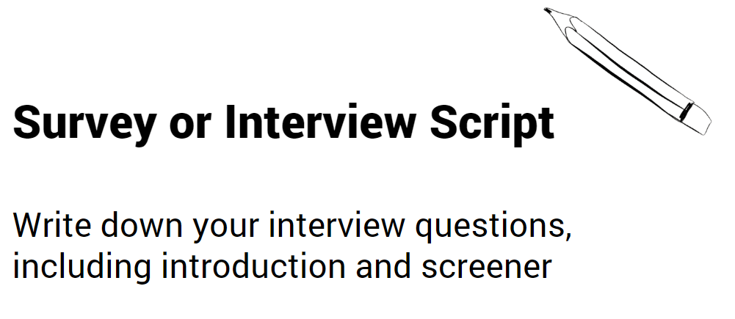_________________________________________________________________________

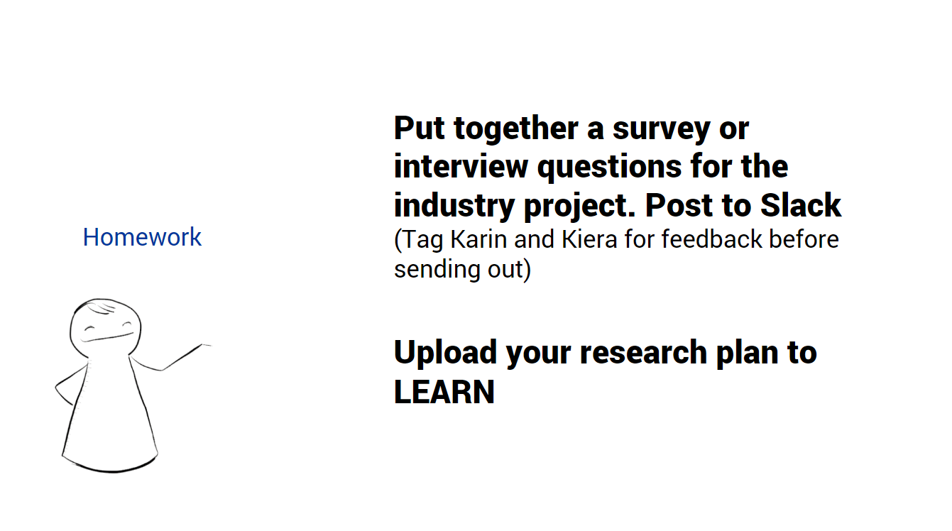

**_________________________________________________________________________**

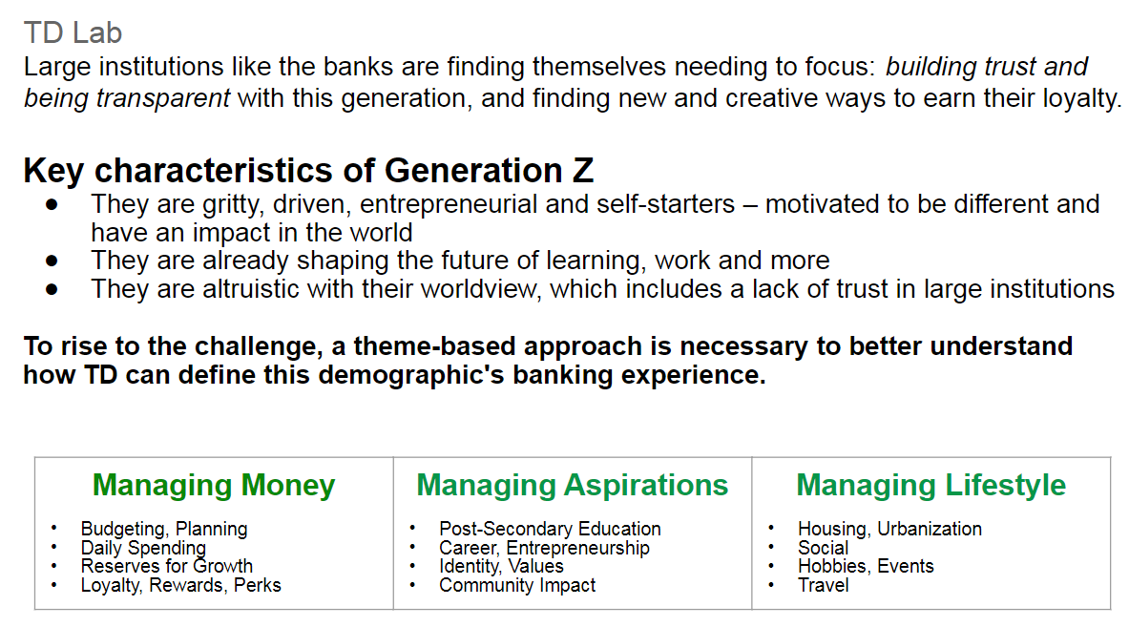

**_________________________________________________________________________**

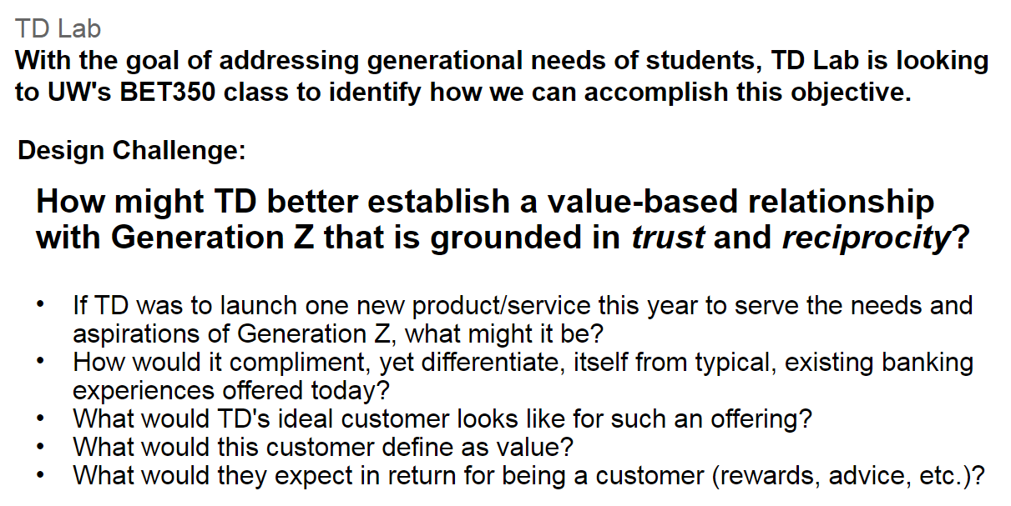

**_________________________________________________________________________**

**Interesting Reads**

<https://www.reddit.com/r/uwaterloo/comments/7zc7zy/student_banking/>

<https://www.reddit.com/r/AskReddit/comments/8hkbsn/whats_the_worst_customer_service_youve_ever/>